Goryslav Sydorenko
COOMET President
NSC “Institute of Metrology”
Kharkov, Ukraine
Phone: +38 057 700 3409
e-mail: coomet@metrology.kharkov.ua

Kharkov
31.01.2008 №33-11/95

Attn COOMET Committee Members
Attn Chairpersons of COOMET Structural Bodies
Attn Chairpersons of Regional Metrology Organizations

Information
on the 18th Meeting of COOMET Committee
and the 6th Meeting of COOMET Joint Committee on Measurement Standards

Dear Colleagues,

The 18th Meeting of COOMET Committee and the 6th Meeting of COOMET Joint Committee on Measurement Standards will be held in May, 2008 at the National Scientific Centre “Institute of Metrology”, in Kharkov, Ukraine. I am glad to invite you to take part in the forthcoming meetings.

Meetings’ Program
13th–14th May | Arrival of the participants of the meetings, welcome & accommodation
14th May | Meeting of COOMET Joint Committee on Measurement Standards
15th–16th May | Meeting of COOMET Committee
Departure of the participants of the meetings according to an individual schedule
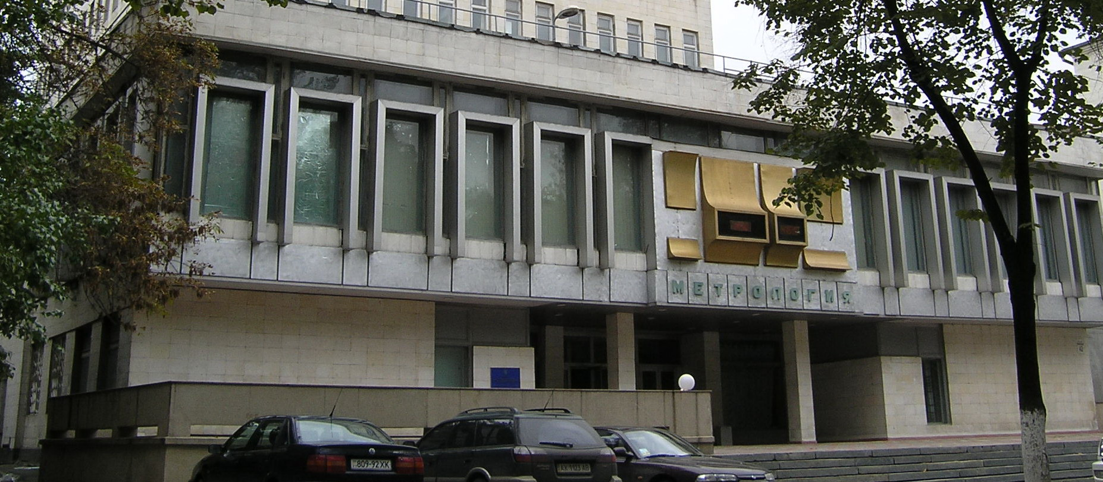
Please confirm your participation in the meetings in advance by filling out the enclosed application form and inform us in case you need personal invitations.

For additional information, please, contact the COOMET Secretariat,
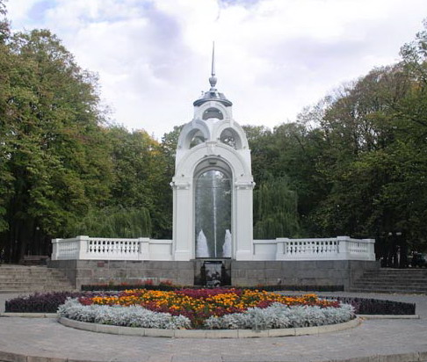
Address: 42 Mironositskaya Str., Kharkov, 61002, Ukraine
Fax: +38 057 700 3447
e-mail: coomet@metrology.kharkov.ua

Dr. Pavel Neyezhmakov ( +38 057 700 3423)
Mrs. Yuliya Bunyayeva ( +38 057 704 9764)
Mrs. Tatyana Omelicheva ( +38 057 704 9764)

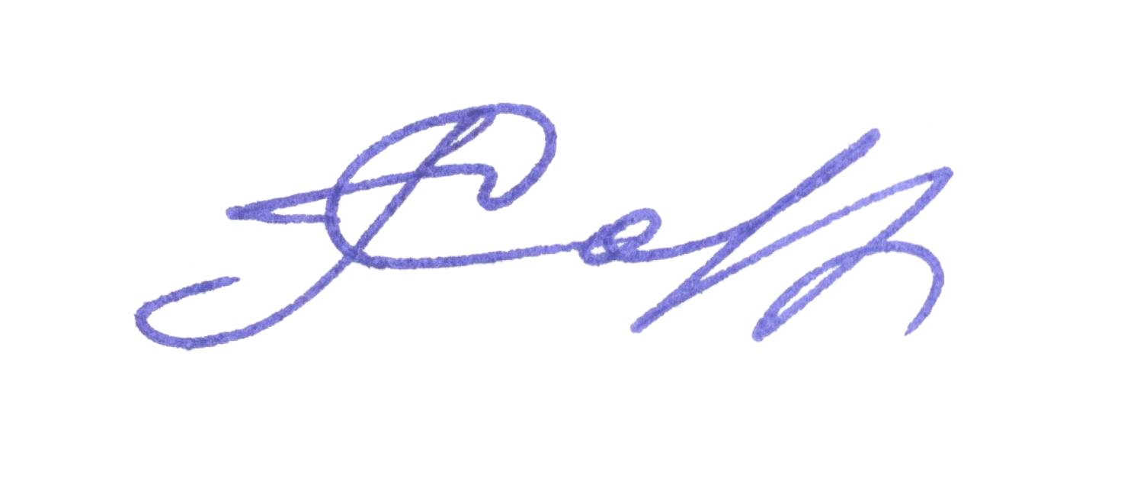
Sincerely yours,

Goryslav Sydorenko
COOMET President

