The results of the 4th International competition
«The best young metrologist of COOMET – 2011»
On 15-17 June of this year in Moscow the 4th International competition “The best young metrologist of COOMET – 2011” was held. Young specialists from Belarus, Germany, Iran (on presentation of PTB, Germany), Kazakhstan, Cuba, Lithuania, Russia, Uzbekistan, Ukraine – in general 18 participants took part in the competition.
In connection with that fact that the competition was conducted during the celebration of 20th anniversary of COOMET foundation, it was combined with the workshop devoted to the COOMET anniversary. Except the greeting speeches of the Head of Rosstandart and VNIIMS as organizers of this event, the following participants took the floor:
- V.I. Belotserkovskiy (for a long time he has presented the USSR and Russia in COOMET Committee) with the report “COOMET traditions is the guarantee of success of cooperation”;
- Manfred Kochsiek (former Vice-President and representative of Germany in COOMET Committee) with the report “COOMET at the very beginning – political context – the original role for NMIs and designated institutes”;
-Hans-Dieter Velfe (former COOMET Vice-President and representative of Germany in COOMET Committee) with the report “COOMET in 1997-2007. Personal thoughts about some key moments and stages of establishment”.
The scope of presented scientific papers of competitors can be divided into three main groups of metrological works:
- Metrological assurance of modern technologies;
- Creation and improvement of standards, instruments and methods of quality unit transfer;
- Metrological assurance of the main problems of economy and social sphere.
Sergey Golubev (VNIIMS, Russia) was announced as the winner of competition with awarding the title “The best young metrologist of COOMET” for the paper “Metrological assurance of scanning probing microscopes on the example of the models Solver and NTegra”.
The second place took Fateme Yagobiyan (Iran) having now the practice in PTB, Germany, she presented the report “Primary standard method quantification of biomarker, based on ID-SERS on single chip”
The third place took Tobias Klein (PTB, Germany) with the report “Traceable measurement of nanoparticle size using a scanning electron microscope in transmission mode”.
In nomination the best report in English won Tatyana Sosnovskaya (BelGIM, Belarus) with the report “Creation and research of National standard of electrical capacity”.
Competitive competition noted the high level of papers of young COOMET metrologists and the quality of presentation of their reports.

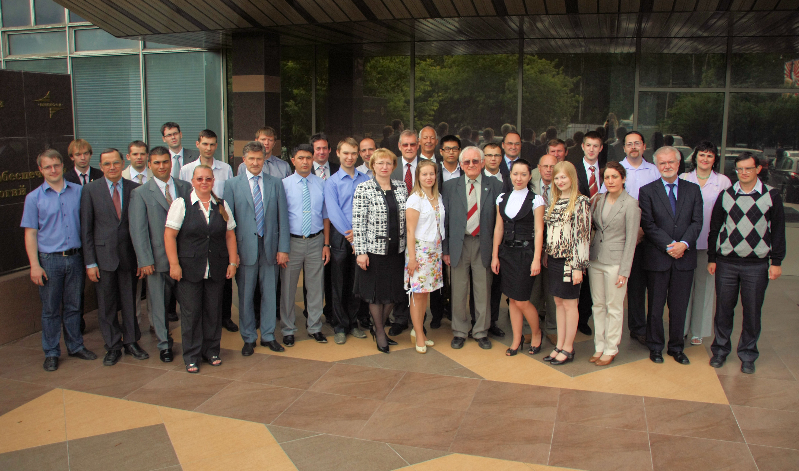

Participants of the 4th International competition “The best young metrologist of COOMET – 2011” and the workshop, devoted to the 20th anniversary of COOMET

