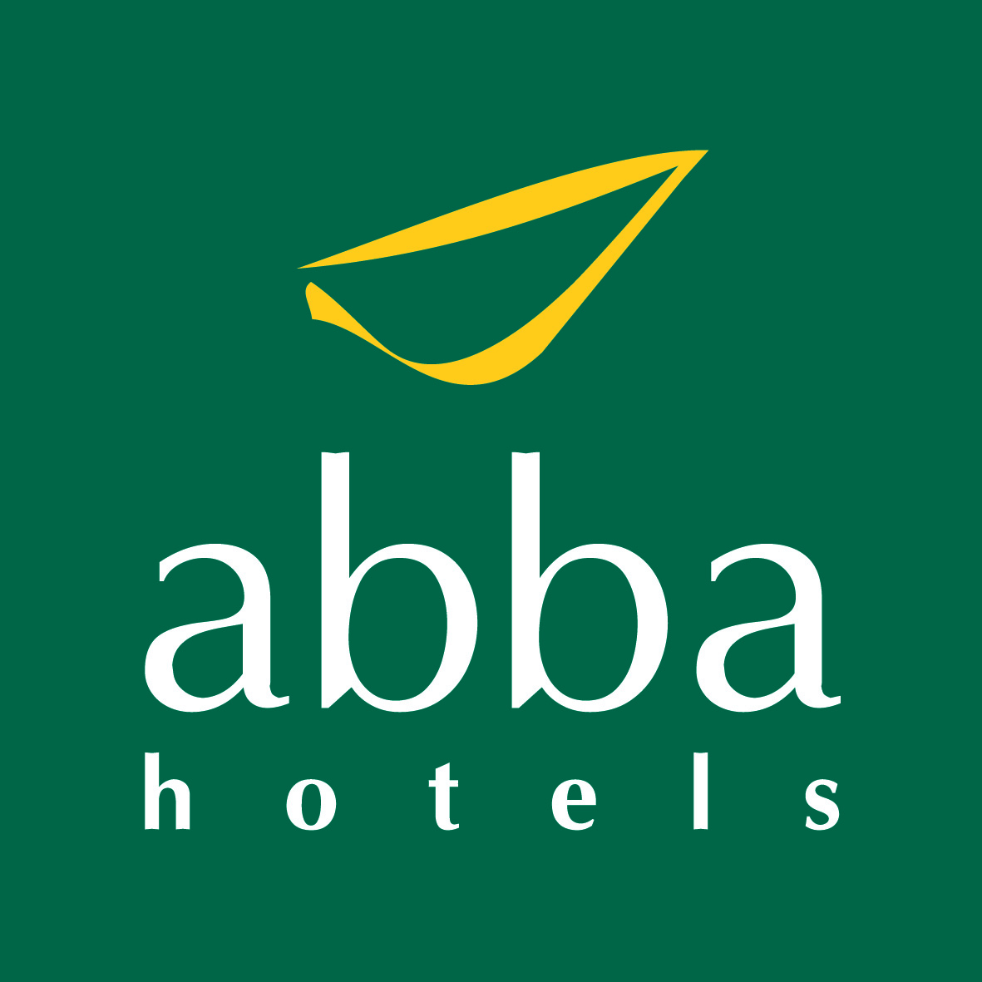
abba Bratislava hotel**** Štefánikova 4 811 05 Bratislava Tel.: +421 (0)2 5751 1000 Fax.: +421 (0)2 5751 1001 E-mail: bratislava@abbahotels.com
booking for “SMU – COOMET”

e-mail: reservations2-bratislava@abbahotels.com or fax: +421 (0)2 5751 1001

RATE:
Standard room (single occupancy): 70 EUR room/ night
Standard room (double occupancy): 75 EUR room/ night
Executive room Additional charge for Executive room is 20 EUR.
Breakfast: included
Garage: 15 EUR/ car/ night
V.A.T. and buffet breakfast included, city tax (1.65 Eur / day / pers.) excluded.

!!! Special rates are available only if this booking form is fully completed and sent back to the hotel before 21.10.2013!!!

GUEST INFORMATION:
Last name: First name:
e-mail: Country:
Date of arrival: Date of departure:

Room type: Standard room (single occupancy)
Standard room (double occupancy)
Executive room (single occupancy)
Executive room (double occupancy)

Other requests: Non-smoking room
Smoking room
Other (please specify): ____________________________

CREDIT CARD DETAILS:

Credit card type: Visa MasterCard AMEX Diners
Cardholder name: _____________________________________________
Credit card number: _____________________________________________
Expiration date: ____________
Please note that reservations without credit card number cannot be processed. Please indicate a card number even if you intend to use another kind of payment.

CANCELLATION POLICY:
Cancellation before 18:00 on the day of arrival is free of charge. If cancelled or modified later or in case of no-show, the first night will be charged.
The hotel reserves the right to ask for credit card authorization or cash deposit upon arrival to assure the payment of the hotel services.

Thank you for having chosen us, we are looking forward to welcoming you in our hotel.

