COOMET PROJECT

FINAL REPORT

1. Ref No.:  213/BY-a/00 | 2. Subject field:  Legal metrology
3. Field of cooperation:
Working up a general approach to testing of software that is integrated in measuring instruments covered by legal metrology requirements.

4 Working Group:
Belarus (BelGIM), Germany (PTB), Ukraine (NSC “Institute of Metrology”, DNDI "System").

5 Subject:
"Development of Recommendation on measuring instrument software testing"

6. Progress:
Recommendation was developed - CООМЕТ R/LM/10:2004 "Software for measuring instruments. General technical specifications"

7 Coordinator’s name: Nikolai Zhagora, Maxim Shabanov
Address: Starovilensky trakt, 93, Minsk, 220053, Belarus
Telephone: +375 17 233-55-01 Fax +375 17 288-09-38 E-mail: coomet@belgim.by

8. Completion date:
31 of October 2008
9. Coordinator's signature:  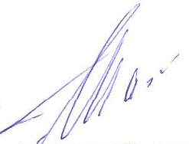   |  | 10. Date:  29.04.2009

