COOMET PROJECT
FINAL REPORT
1 Ref. №:  453/BY-a/09 |  | 2 Subject field:  Training and improvement of professional skill
3 Field of cooperation:

Training and improvement of professional skills of specialists
4 Working Group:

Belarus, Cuba, DPR of Korea, Germany, Russia, Slovakia, Ukraine, Uzbekistan

5 Subject:

Organization and conduction of III competition of young metrologists of COOMET countries members 14 – 15 of April 2009 in Minsk, Belarus

6 Progress:

14-15 of April 2009 there was hold in Minsk (Belarus) the III International competition “The best young metrologist of COOMET 2009”,

According to the decision of competition commission the 1st place took Nataliya Chervjakovskaja (BelGIM, Belarus), the 2nd place took Makram A. Zebian (PTB, Germany), the 3rd place took Dmitry Gogolev (VNIIMS, Russia). With a special prize for the best report in English was awarded Dmitry Solomakho (BNTU, Belarus).

7 Coordinator’s name:
Лобко Владимир Павлович  Ляхова Надежда Дмитриевна  Адрес: БелГИМ, Беларусь г. Минск, Старовиленский тракт, 93  Телефон: +375 17 334-75-40  Факс: +375 17 288-09-38  E-mail: coomet@belgim.by |  |  | Аннета Кеглер  Адрес: Государственный физико-технический институт (ПТБ), Бундесаллее 100, 38116, Брауншвейг, Германия  Телефон: +49 531 592 82 13  Факс: +49 531 592 82 25  E-mail: Annette.Koegler@ptb.de
8 Completion date:

15.04.2009
9 Coordinator’s signature: |  |  |  | 10 Date:  20.04.2009
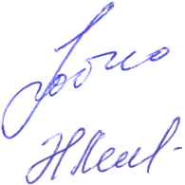 | 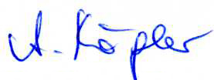 |  |  | 10 Date:  20.04.2009

