COOMET PROJECT
FINAL REPORT
1 Ref. №:  509/BY-a/10 |  | 2 Subject field:  Ionising radiation and Radioactivity
3 Field of cooperation:
Consultancy and training
4 Working Group:
Azerbaijan, Belarus, Germany, Cuba, Moldova, Russia, Ukraine

5 Subject:

Organization and conducting the 9 meeting of COOMET Technical Committee 1.9 "Ionising radiation and Radioactivity"
6 Progress:

There was the 9 meeting of COOMET Technical Committee 1.9 "Ionising radiation and Radioactivity" on the 2-3 of November 2010 in Minsk, Belarus, where 18 representative from National Metrological Institutions of COOMET member-countries were taking part.

7 Coordinator’s name:
Vladimir LOBKO, First Deputy Director  Valery MILEVSKY, Head of Department  Address: BelGIM, Belarus, Minsk  Starovilensky tract 93  Tel.: +375 17 233-62-25, 233-65-04  Fax: +375 17 288-09-38  E-mail: coomet@belgim.by |  |  | Prof. Dr. Vladimir Yarina  Address: VNIIFTRI, 141570 Mendeleevo, Moscow Region, Russia  Tel.: +7 496 266 25 76  Fax: +7 495 744 81 75  E-mail: ir@vniiftri.ru
8 Completion date:

03.11.2010
9 Coordinator’s signature: |  |  |  | 10 Date:  03.01.2011
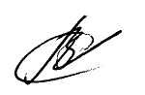 | 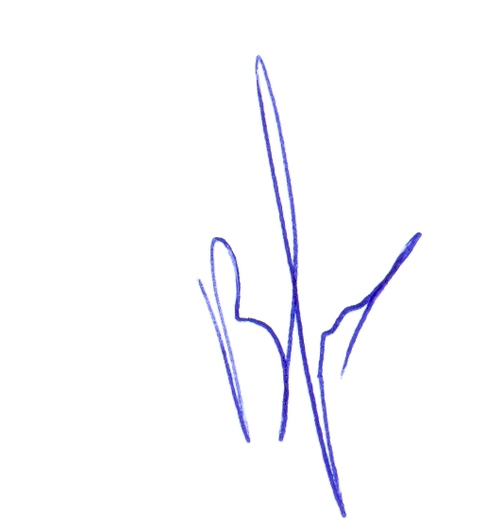 |  |  | 10 Date:  03.01.2011

