COOMET PROJECT
FINAL REPORT
1 Ref No.:  251/BY-а/01 | 2 Subject field:  Improvement of COOMET activities
3 Field of cooperation:
Information Technology - Improvement of COOMET Web-site
4 Working Group:
BelGIM (Belarus), PTB (Germany), Moldova-Standard (Moldova), VNIIMS and VNIIFTRI (Russia), NSC “Institute of Metrology” (Ukraine), KazInMetr (Kazakhstan)

Coordinators:
- COOMET Secretariat (NSC “Institute of Metrology”)
- COOMET Vice-president responsible for informational support and promotion of new information technologies
- VNIIFTRI, VNIIMS

5 Subject:
Development and realization of suggestions for improvement of COOMET Web-site

6 Progress:
The activities under this project should be considered completed in view of a new project.

7 Coordinator’s name: Dr. Pavel Neyezhmakov,

Head of the COOMET Secretariat
Address: National Scientific Center “Institute of Metrology”
42, Mironositskaya Str, 61002, Kharkov, Ukraine

Telephone: +38 057 700 3423
Fax: +38 057 700 3447
E-mail: pavel.neyezhmakov@metrology.kharkov.ua
coomet@metrology.kharkov.ua

8 Completion date:

4.09.2010
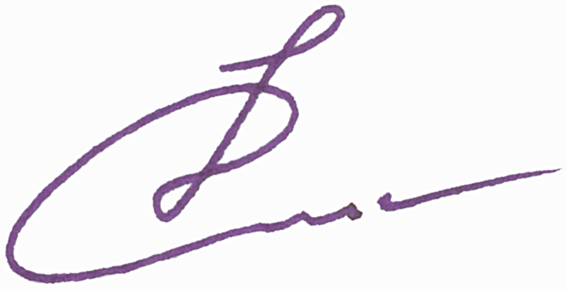  9 Coordinator’s signature: |  | 10 Date:  09.03.2010

