COOMET PROJECT
PROGRESS/FINAL REPORT
1 Reference No.:  265/UA/02 | 2 Subject Field:  Length and angle
3 Field of cooperation:
Comparisons
4 Working Group:
NSC “Institute of Metrology”, Ukraine
KazInMetr, Kazakhstan

5 Subject:
Conducting of standards measuring instruments comparisons with aim of unity and reliability of length measurements

6 Progress:
In the course of the comparisons of the planned participants was excluded VNIIM, referring to technical complications.
KCDB Registration Number COOMET.L-S3
Supported СМС: 2.2, 2.2.1
Finished. Final report has been prepared.

7 Coordinator’s name: Kupko V.S.

Address: 61002, Kharkov, Mironositskaya St., 42, NSC “Institute of metrology”, Ukraine

Telephone: (057)700-34-09 Fax: (057)700-34-47 E-mail: kupko@metrology.kharkov.ua

8 Completion date:
December 2010
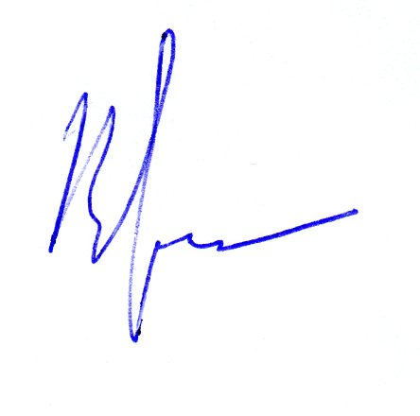  9 Coordinator’s signature: |  | 10 Date:  12.10.2011

