COOMET PROJECT
PROGRESS/FINAL REPORT
1 Reference No.:  277/UA-a/03 | 2 Subject Field:  Length and angle
3 Field of cooperation:
Comparisons
4 Working Group:
NSC “Institute of Metrology”, Ukraine
VNIIM, Russian Federation
RSE “KazInMetr”, Kazakhstan

5 Subject:
Conducting of standard measuring instruments comparisons with aim of unity and reliability of length measurements

6 Progress:
Finished. Final report has been prepared.
KCDB Registration Number COOMET.L-S1
7 Coordinator’s name: Kupko V.S.

Address: 61002, Kharkov, Mironositskaya St., 42, NSC “Institute of Metrology”, Ukraine

Telephone: (057)700-34-09 Fax: (057)700-34-47 E-mail: kupko@metrology.kharkov.ua

8 Completion date:
December 2010
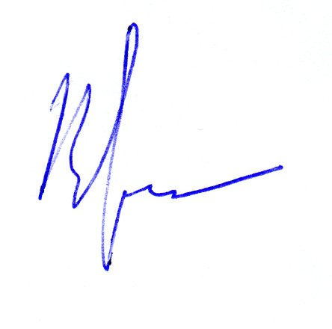  9 Coordinator’s signature: |  | 10 Date:  14.09.2011

