COOMET PROJECT
PROGRESS/FINAL REPORT
1 Ref. №:  310/UA-а/04 | 2 Subject field:  TEMPERATURE AND THERMAL PHYSICS
3 Field of cooperation:
Conducting comparisons of standard measuring instruments with the aim of assuring the uniformity and reliability of measurements
4 Working Group:
NSC “Institute of Metrology”, Ukraine; FGUP “UNIIM”, Russian Federation

5 Subject:
Conducting comparisons of the standards of specific heat of solids

6 Progress: Comparisons of the national measurement standards of the unit of specific heat of solids of the NSC “Institute of Metrology”, Ukraine, and FGUP “UNIIM”, Russian Federation, have been conducted. The results of the comparisons are given in Report B.

7 Coordinator’s name: Vasiliy P. Slipushenko

Address: National Scientific Center “Institute of Metrology”, 42, Myronosytska St., Kharkiv, Ukraine, 61002
Tel.: +380 057 7049806 Fax: +380 057 7003447 E-Mail: vsl@metrology.kharkov.ua

8 Completion date: 4 ^{th} quarter of 2007

9 Coordinator’s signature:  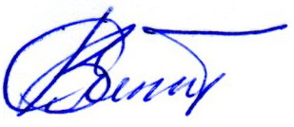 |  | 10 Date:  03.12.2008

