COOMET PROJECT
FINAL REPORT
1 Ref. №:  314/UA/04 | 2 Subject field:  LENGTH AND ANGLE
3 Field of cooperation:

International comparison of primary measurement standards
4 Working Group:

Bulgaria, Germany, Kazakhstan, Russia, Ukraine

5 Subject:

Comparison of the involute surface standards

6 Progress:

A comparison of measurement standards of Russia and Ukraine was carried out in order to assure the mutual recognition of the results of testing and certifying measuring instruments. Reports of A and B types were drawn up and approved. Type B report was submitted to COOMET Secretariat. The participation of Ukraine in the key comparisons of the EU was confirmed.

7 Coordinator’s name: Vladimir Kupko

Address: Research Laboratory 21, 42 Mironositskaya Str., 61002 Kharkov, Ukraine

Tel: 7049854

Fax: 7003409

Email: kupko@metrology.kharkov.ua

8 Completion date:

October 2008
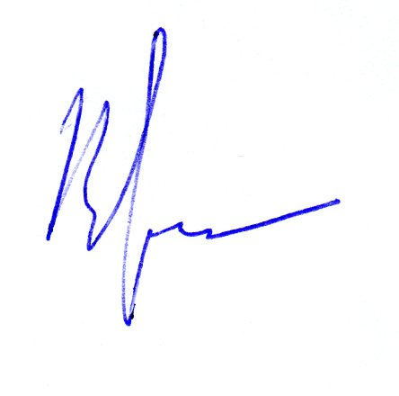  9 Coordinator’s signature: |  | 10 Date:  29.10.2008

