COOMET PROJECT
FINAL REPORT
1 Reference No.:  347/RU-а/05 |  | 2 Subject field:  General metrology
3 Field of cooperation:
Research
4 Working group:
No working group for this project was formed. The draft recommendation was discussed at COOMET TC1.1 meetings.
5 Subject:
The possibility of combined use of the concepts “error of measurement” and “uncertainty of measurement” for various metrological tasks
6 Progress:
The work under the project is completed.
The COOMET Recommendation R/GM/21:2011 “Use of concepts ‘error of measurement’ and ‘uncertainty of measurement’. General principles” is available in Russian and English on the COOMET website at: http://www.coomet.org/RU/doc/r21_2011.pdf, http://www.coomet.org/EN/doc/r21_2011.pdf.

7 Coordinator's name:
A.Doynikov
Address: VNIIFTRI, 141570, Russia, Moscow Region, Mendeleevo
Tel/Fax: +7 495 744 81 78, E-mail: doynikov@vniiftri.ru
8 Completion date:
The Recommendation was approved by the COOMET Committee in its 21st meeting on April 27-28, 2011 (in Yerevan, Armenia).
9 Coordinator's signature: 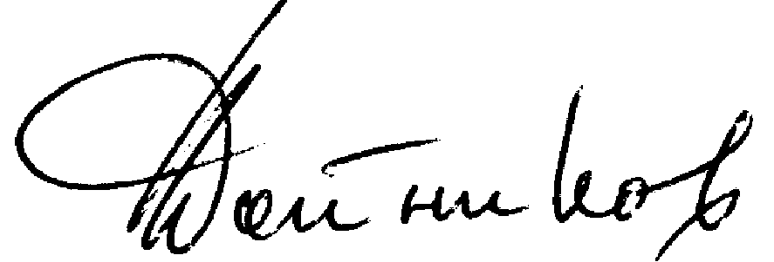 | 10 Date:  04.04.2012

