COOMET PROJECT
FINAL REPORT
1 Ref. №:  382/RU/07 | 2 Subject field:  Length and angle
3 Field of cooperation:
International comparisons of primary standards and lower-level standards
4 Working Group:
BelGim (Belarus), RGP “KazInMetr” (Kazakhstan), FGUP “UNIIM” Russia

5 Subject:
International comparisons of national standards in the field of deviations from straightness and flatness within the measurement range of deviations from straightness from 0 to 50 mkm, the length of surface from 0,4 to 5 m

6 Progress:
Comparison procedure was developed, the pilot comparison of primary standards of Belarus, Kazakhstan and Russia was conducted. Type B report was prepared and agreed upon. From the comparison results the conclusion on the repeatability of measurements of national standards in the
field of deviations from straightness and flatness was drawn. The report is submitted to COOMET Secretariat.
The work on the project is finalized.
In future key comparison of these standards is planned within a new project.

7 Coordinator’s name: V. Leonov, Director of UNIIM

Address: 4, Krasnoarmeyskaya Str., Yekaterinburg, 620000, Russia

Telephone: (343) 350-26-18 Fax: (343) 350-20-39 E-mail: uniim@uniim.ru

8 Completion date:
May 2008
9 Coordinator’s signature:  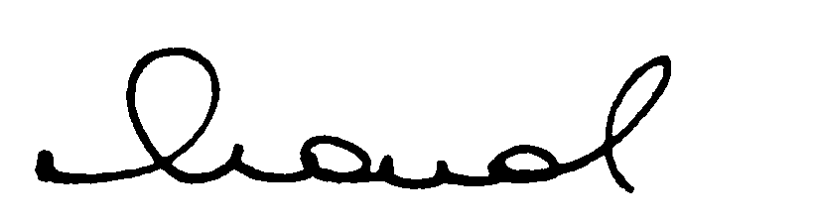 |  | 10 Date:  10/12/2008

