COOMET PROJECT
FINAL REPORT
1 Ref. №:  383/UA/07 | 2 Subject field:  GENERAL METROLOGY
3 Field of cooperation:

Transfer of unit dimensions from primary standards to working measuring instruments
4 Working Group:

NSC “Institute of Metrology” (Ukraine), VNIIFTRI (Russia)

5 Subject:

Development of the order of formation and implementation of the Program of Calibrations of National Measurement Standards of COOMET NMIs

6 Progress:
A questioning of the Chairpersons of TCs 1.1–1.12 was made.
In accordance with the information received 11 Chairpersons refused the Program of Calibrations and 1 Chairperson supported.
The results of the questioning were discussed during the 6th meeting of COOMET JCMS. All TC Chairpersons or their representatives expressed the opinion the uselessness of the project.
Since calibration is a commercial kind of activity controlled by bilateral agreements and based on the results of the questioning and the 6th meeting of COOMET JCMS a decision was made not to continue the activity with regard to the creation and development of the Program of Calibration of National Measurement Standards of COOMET NMIs. The project should be finished.

7 Coordinator’s name:
Pavel Neyezhmakov  The address: National Scientific Centre  “Institute of Metrology”,  42, Myronosytska Str., Kharkоv, Ukraine  Tel.: +38 (057) 704-98-51  Fax: +38 (057) 700-34-47  e-mail: pavel.neyezhmakov@metrology.kharkov.ua |  | Sergei V. Korostin  Address: VNIIFTRY , 141570,  Mendeleevo, Solnechnogorsk district, Moscow region, Russia,  Tel: +7 495 535 91 02  Fax: +7 495 535 93 05  e-mail: ir@vniiftri.ru
8 Completion date:

1.09.2008
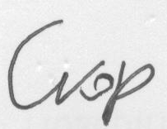  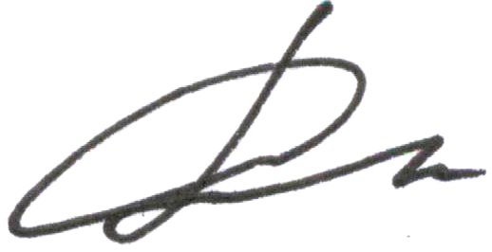  9 Coordinator’s signature: |  |  | 10 Date:  29.10.2008

