COOMET PROJECT
FINAL REPORT
1 Ref. №:  391/RU-а/07 | 2 Subject field:  Information and information technology
3 Field of cooperation:
Advice and training
4 Working Group:
FGUP «VNIIMS» (Russia)
Service of Standardization and Metrology of Republic of Moldova («Moldova-Standard»)
Belarussian State Institute of Metrology (BelGIM)

5 Subject:
Development of the recommendations for specialists probation programs’ contents in the framework of COOMET

6 Progress:
An analysis of the organization and the process of on-site training for foreign specialists as well as of the experience in other countries was made.
As a result of the analysis there are essential differences in the purposes, forms, and periods of on-site training as well as in the level of preparing the specialists.
At the 7th meeting of TC 4 a decision was made to close the project in view of initiating a new project on the content of the programme of on-site training for carrying out calibration, comparisons and implementing quality management systems.

8 Coordinator’s name: Ivanov V.Y., VNIIMS

Address: 46, Ozernaya str., 119361 Moscow, Russia

Phone: +7 (495) 437 37 47 Fax: +7 (495) 437 37 47 e-mail: vivanov@vniims.ru

8 Completion date:
30.06.2010

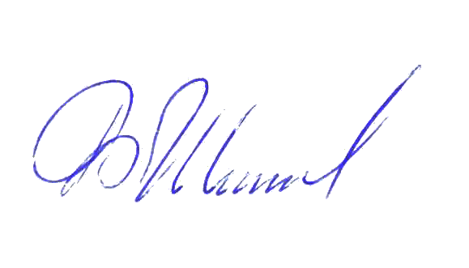  9 Coordinator’s signature: |  | 10 Date:  25.08.2010

