COOMET PROJECT

FINAL REPORT

1. Ref No.:  393/RU/07 | 2. Subject field:  Training and qualification upgrade
3. Field of cooperation:
Memorandum, part 4, p.4
4 Working Group:
FGUP «VNIIMS» (Russia)
Service of Standardization and Metrology of Republic of Moldova («Moldova-Standard»)
Belarussian State Institute of Metrology (BelGIM)
Kazakhstan (KazInMetr)

5 Subject:
Development of the assessment criteria for the experts-metrologists’ qualification

6. Progress:
Developed criteria are the requirements to the competence of the metrologists, who work or research in fields:
Accreditation of the laboratories and centres for different kind of metrological activities;
Testing of measuring instruments, systems and failure samples;
Certification of measuring instruments and systems, software of measuring instruments, quality management systems, failure samples;
Approval of testing equipment, measuring methods, reference materials of the composition and features of the substances and materials;
Expert evaluation of the projects of technical regulations, programs and national standards, technology and engineering documents.
Project is closed during the TC 4 meeting on the 28.04.2009 in Braunschweig (Germany).

7 Coordinator’s name: Ivanov V.Y., VNIIMS
Address: 46, Ozernaya str., 119361 Moscow, Russia

Phone: +7 (495) 437 37 47 Fax: +7 (495) 437 37 47 e-mail: vivanov@vniims.ru

8. Completion date:
28.04.2009
9. Coordinator's signature:  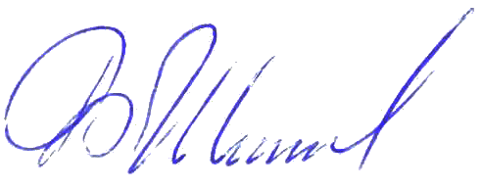 |  | 10. Date:  22.06.2009

