COOMET PROJECT
FINAL REPORT
1. Ref. №: |  | 2. Subject field:  Physical chemistry (Gas analysis)
401/RU-a/07
3. Field of cooperation:
Comparisons
4. Working Group:
L.A. Konopelko (VNIIM, Russia), Y.A. Kustikov (VNIIM, Russia), E.V. Gromova (VNIIM, Russia), M.S. Rozhnov (Ukrmetrteststandart, Ukraine), V.N. Ananyin (BelGIM, Belarus), A.S. Kluchits (BelGIM, Belarus), H.-J. Heine (BAM, Germany)

5. Subject:
Key comparison of standard samples of CO in Nitrogen gas mixtures (100 and 1000 ppm)
6. Progress:

The work on the comparison of CO in Nitrogen gas mixtures has been finished. The final report of the comparison is sent to the participants. The results of the comparison were used by the participants for calibration and measurement capabilities preparing.

7. Coordinator’s name: | Prof. Leonid A.Konopelko  Chairman of TC 1.8 “Physical chemistry“ COOMET
Address: | D.I.Mendeleyev Institute for Metrology  19, Moskovsky pr., St.Petersburg, 190005 Russia
Telephone: | +7 812 315 11 45
Fax: | +7 812 327 97 76
E-mail: | lkonop@b10.vniim.ru
8. Completion date:
November 2009
9. Coordinator’s signature:  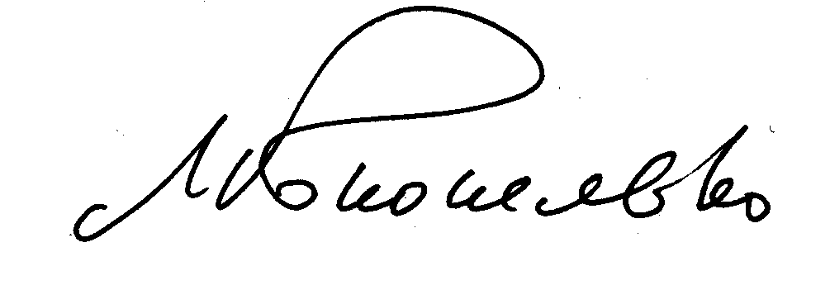 |  |  | 10. Date:  16.12.2009

