COOMET PROJECT
FINAL REPORT

1. Ref:  405/RU-a/07 | 2. Subject Field :  ACOUSTICS. ULTRASOUND. VIBRATION
3. Type of cooperation:
Comparison

4. Partners:
DNDI “Systema”, (Ukraine), FGUP VNIIFTRI (Russia)

5. Subject:
Comparisons of the sound pressure standards in water in the low frequency and in infrasound frequency range (from 2 kHz to 4 kHz)

6. Description:
The sources of uncertainty of the pressure hydrophones calibration in closed chambers at the third-octave frequencies in the frequency range from 2 Hz to 4 kHz have been Investigated. The techniques of comparisons of the Russian primary standard of sound pressure unit in water and the Ukrainian primary underwater acoustic standard have been worked out

7. Additional remarks:
The equivalence of the national standards of participating NMIs was confirmed

8. Coordinator’s name: Isaev A. E.

Address: Moscow region 141570, Russia, VNIIFTRI

Phone: +7 (495) 660-21-66 Fax : +7 (495) 535-93-13, +7 (495) 660-25-39

E-mail: isaev@vniiftri.ru, nekrich53@mail.ru

9. End date:
16 December 2008
10. Coordinator’s signature:  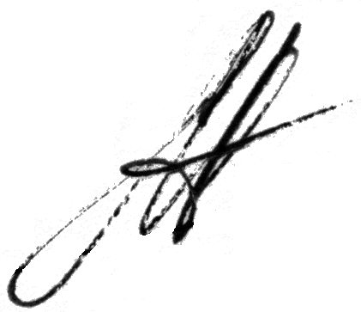 |  | 11. Date:  3 June 2011

