COOMET PROJECT

FINAL REPORT

1. Ref No.:  430/BY-a/08 | 2. Subject field:  Legal metrology
3. Field of cooperation:
Taking part in the meeting of COOMET Technical Committee
4 Working Group:
Representative from TC 2 country-members participated at the meetings: Belarus (BelGIM, Gosstandart), Germany (LMET), Lithuania (VMC), Russia (VNIIMS), Ukraine (NSC “Institute of Metrology”, DNDI "System").

5 Subject:
Arranging and holding of the COOMET Technical Committee TC 2 “Legal metrology” meeting

6. Progress:
The meeting of COOMET Technical Committee TC 2 was held on 16 – 17 of September 2008 in BelGIM, Minsk, Belarus
Proceedings: Minutes of TC 2 meeting.

7 Coordinator’s name: Nikolai Zhagora
Address: Starovilensky trakt, 93, Minsk, 220053, Belarus
Telephone: +375 17 233-55-01 Fax +375 17 288-09-38 E-mail: coomet@belgim.by

8. Completion date:
17 of September 2008
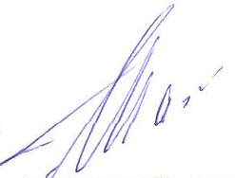  9. Coordinator's signature: |  | 10. Date:  31.10.2008

