COOMET PROJECT
FINAL REPORT
1. Ref No.:  456/RU-a/09 | 2. Subject field:  CERTIFIED REFERENCE MATERIALS
3. Field of cooperation: Development and use of certified reference materials of composition and properties of substances and materials.

4. Working Group:
Belarus, Germany, Kazakhstan, Russia, Ukraine

5. Subject:
Organization and conducting the 14th meeting of COOMET Technical Committee 1.12 “CERTIFIED REFERENCE MATERIALS” (COOMET TC 1.12 “CRMs”).
6. Description:
The 14th meeting of COOMET TC 1.12 “CRMs” was organized and conducted on 12-16 October 2009 (Minsk, Belarus). 22 representatives from 5 COOMET member-countries, including Deputy Chairman of Gosstandart of Belarus Mr. S. Ivlev and COOMET Vice-President, Director of BelGIM Mr. N. Zhagora took part in the work of the 14th meeting of COOMET TC 1.12 “CRMs”. The following questions were considered: the outcome of the finalized projects in the subject-field “Certified Reference Materials”; the progress of the current projects; proposals on new projects; the problems, related to the ideology of works on CRM development, the harmonization of national documents of the countries with COOMET documents on CRMs and the documents of other international organizations; the results of the 7th meeting of COOMET JCMS and the 19th meeting of COOMET Committee; the information on CRM activity within international organizations ISO/REMCO, COMAR, OIML TC 3/SC 3, CIS, etc. The decisions, taken at the 14th meeting of COOMET TC 1.12 “CRMs” are set out in the Minutes No. 14-2009.

7. Coordinator’s name: Prof. Vladislav V. Leonov,
Chairman of COOMET TC 1.12 “Certified Reference Materials”,
Director of the Urals Research Institute for Metrology (UNIIM)
Address: 4, Krasnoarmeyskaya Str., 620000, Yekaterinburg, Russia

Telephone: (343) 350 26 18 Fax: (343) 350 20 39 E-mail: uniim@uniim.ru
E-mail: intermetron@uniim.ru

8. Expected completion date:
October 2009

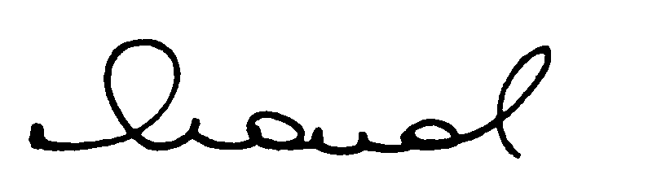  9. Coordinator’s signature: |  | 10. Date:  November 2009

