FINAL COOMET PROJECT

1 Ref No.:  470/RU-a/09 | 2 Subject field:  Electricity and Magnetism
3 Field of cooperation:
Comparisons
4. Working Group:
Zaharov B.V. FGUP “UNIIM” (Russia), Kikalo V.N., Ukrmetrteststandart (Ukraine)

5 Subject:
Pilot comparisons of national standards in the field of measuring the ratio and angle scaling conversion of sinusoidal current (MPST) in the range 1 … 10000A/5A(1A)

6 Current status of work:
Work on comparisons of standards in Russia and Ukraine were conducted in accordance with the technical protocol. Comparisons were made between the two NMI - UNIIM (Russia) and Ukrmetrteststandard (Ukraine). These measurement results and uncertainties are stated in the final report. Estimation of data comparisons has been performed. Criteria values consistency NMI is defined. All the obtained values do not exceed the corresponding critical values for all values of current by provided technical protocol. All data provided by NMI - members of comparisons are recognized as compatible. Conclusion about the possibility and feasibility of the key comparisons involving NMI other countries - members COOMET - soon (2012 - 2014 years) has been made.
7 Coordinator Name: Zaharov B.V.
Address: FGUP “UNIIM”, 4, Krasnoarmeiskaya ul., Ekaterinburg, 620000, Russia

Telephone: 8.343 350 20 65 Fax: 8.343 3502313 e-mail: lemma@uniim.ru, sichev@uniim.ru
8 Date of completion of works:
31.03.2011

9. Signature of Coordinator:  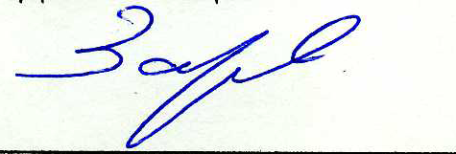 |  | 10. Date:  11.05.2011

