COOMET PROJECT
FINAL REPORT
1 Ref. №:  472/AM/09 | 2 Subject field:  INFORMATION AND TRAINING
3 Field of cooperation:
Information and training
4 Working Group:

26 representatives of 11 Member-Countries took part in the workshop: Armenia (NIM RA), Belarus (BelGIM), Germany (РТВ), Georgia (GEOSTM), Kazakhstan (RSE “KazInMetr”), Kyrgyzstan (NISM), Russia (VNIIMS, VNIIPTRI), Slovakia (SMU), Tajikistan (TAJIKSTANDART), Uzbekistan (NSC RU), Ukraine (NSC «Institute of Metrology»)

5 Subject:
Preparing and conducting the workshop “Calibration and Verification - Differences between Obligatory and Facultative Measurements”

6 Progress:
The workshop was held on 13-15 June, 2009, Yerevan, Armenia.
During the workshop it was to consider terminological and organizational aspects of calibration and verification for 4.5 members, national standard keepers and collaborators of NMI of countries of Central Asia and Transcaucasia, which take part in conduction of verification and calibration works.
Proceeding: Minutes of the workshop.

7 Coordinator’s name:

Mr. Kamo Movsisyan  The address: National Institute of Metrology RA, 0051, Erevan, Komitas av. 49/2, RA  Tel.: +374 10 24 45 54  Fax: +374 10 23 54 78  E-mail: movsisyan@metrology.am |  | Annette Koegler  The address: Physikalisch-Technische Bundesanstalt (PTB), Braunschweig und Berlin, Bundesallee 100, 38116 Braunschweig, Germany  Tel: +49 531 592 82 13  Fax: +49 531 592 82 25  E-mail: Annette.Koegler@ptb.de
8 Completion date:
15.07.2009
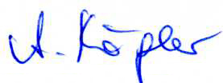  9 Coordinator’s signature:  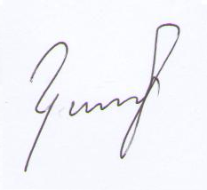 |  |  | 10 Date:  09.03.2010

