COOMET PROJECT
FINAL REPORT

1. Ref:  473/RU-a/09 | 2. Subject Field :  ACOUSTICS. ULTRASOUND. VIBRATION
3. Type of cooperation:
Comparisons

4. Partners:
VNIIFTRI (Russia), HAARI (China)

5. Subject:
Pilot study of the sound pressure standards in water (for free-field calibration) in the frequency range 250 Hz to 200 kHz

6. Description:
The new techniques of free-field hydrophones calibration in reverberant water tank have been tested, the sources of measurement uncertainty were studied and uncertainty of hydrophone calibration has been estimated. The resulting estimates have been confirmed by comparing the calibration results performed with the use of new techniques and traditional methods of free-field and pressure hydrophones calibration. The resulting convergence of the calibration results confirmed the possibility to extend through the new techniques application the frequency range of the free-field hydrophone calibration in a laboratory reverberant water tank of typical sizes to the low-frequency region for at least on decade in comparison with the traditional method of the direct projector signal time selection

7. Additional remarks:
The results of the pilot comparisons allow to expand opportunities of sound pressure receivers’ free-field calibration and to improve the CMC-data of participants. For this purpose agreed to organize а re-comparisons of the results of hydrophone free-field calibrations at low frequencies with the status of supplementary comparisons

8. Coordinator’s name: Isaev A.E.

Address: 141570 Mendeleevo Moscow region RUSSIA

Phone: +7 (495) 660-21-66 Fax: +7 (495) 660-25-39 e-mail: isaev@vniiftri.ru

9. End date:
20 December 2010
10. Coordinator’s signature:  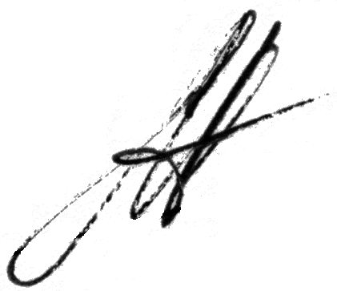 |  | 11. Date:  3 June 2011

