CООМЕТ PROJECT
FINAL REPORT
1 Ref No.:  476/GE/09 | 2 Subject field:  Information and training
3 Field of cooperation:
Consulting and Training

4 Working group:
Republic of Armenia, Republic of Azerbaijan, Republic of Belarus, Georgia, Federal Republic of Germany, Republic of Kazakhstan, Kyrgyz Republic, Slovak Republic, Republic of Tajikistan, Ukraine, Republic of Uzbekistan

5 Subject:
Organization and conducting of a COOMET workshop on “Implementation of Quality Management Systems at NMIs according to ISO/IEC 17025” (October 14–16, 2009, Tbilisi, Georgia)

6 Progress:
Three-day COOMET workshop on “Implementation of Quality Management Systems at NMIs according to ISO/IEC 17025” was conducted on October 14–16, 2009 in Tbilisi, Georgia, where representatives of the field of Metrology from 11 COOMET member-countries
7 Coordinator’s name:
Nino Mikanadze  Address: Georgian National Agency for Standards, Technical Regulations and Metrology (GEOSTM),  67 Chargali str, 0141 Tbilisi, Georgia  Tel.: +995 32 61 35 00  Fax: +995 32 61 35 00  E-mail: nino_mikanadze@yahoo.com |  | Annette Koegler  Address: Physikalisch-Technische Bundesanstalt (PTB), Braunschweig und Berlin, Bundesallee 100, 38116 Braunschweig, Germany  Tel: +49 531 592 82 13  Fax: +49 531 592 82 25  E-mail: Annette.Koegler@ptb.de
8 Completion date:
17.10.2009

9 Coordinator’s signatures  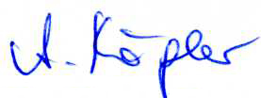  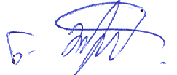 |  |  | 10. Date:  05.12.2011

