COOMET PROJECT
FINAL REPORT
1. Ref. №: |  | 2. Subject field:  Physical chemistry
493/RU-a/10
3. Field of cooperation:
Comparisons
4. Working Group:
D.I. Mendeleyev Institute for metrology (VNIIM), Russia
Federal Institute for Materials Research and testing (BAM), Germany
Moscow State University (MGU), Russia.
Petersburg’ Institute of Nuclear Physics (PINP), Russia.
Carbon Technologies & Materials (CT&M), Russia.
5. Subject:
Bilateral comparison: Determination of fullerenes C60 and C70 mass fraction in fullerene concentrate
6. Progress:
The work on the comparison has been finished. The final report of the comparison is sent to the participants.

7. Coordinator’s name: | Prof. Leonid A.Konopelko  Chairman of TC 1.8 “Physical chemistry“ COOMET
Address: | D.I.Mendeleyev Institute for Metrology  19, Moskovsky pr., St.Petersburg, 190005 Russia
Telephone: | +7 812 315 11 45
Fax: | +7 812 327 97 76
E-mail: | lkonop@b10.vniim.ru
8. Completion date:
December 2010
9. Coordinator’s signature:  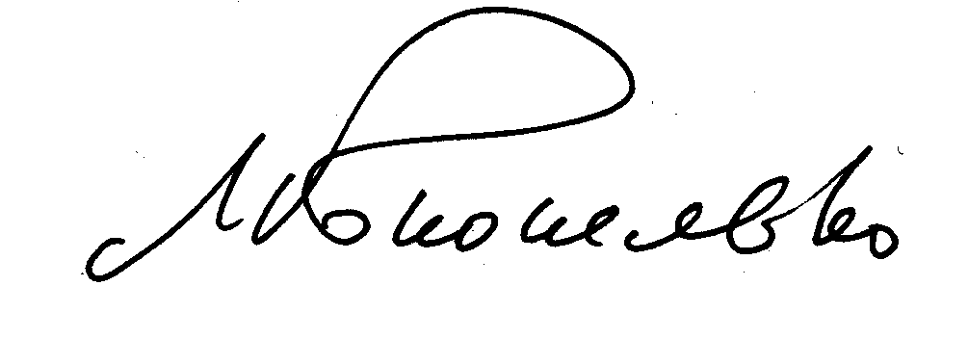 |  |  | 10. Date:  16.12.2010

