COOMET PROJECT
FINAL REPORT
1 Ref. №:  495/RU-а/10 | 2 Subject field:  Thermometry AND Thermophysics
3 Field of cooperation:
Participation in CIPM key comparisons of national measurement standards and realization of regional comparisons of measurement standards

4 Working Group:
Nikolay Sokolov (VNIIM, Russian Federation), Baurjan Muchamedjanov (Kazakhstan Institute of Metrology, Kazakhstan)

5 Subject:
The pilot thermal conductivity comparison in the range from 0.03 to 0.05 W·m-1·K-1 at temperature from 10 to 40 ºC

6 Progress:
Process on a theme are finished. The report “B” is prepared and issued.
Results of works are reported on 4th All-Russia and the countries-participants KOOMET of conference for problems of thermometry of 19-21.04.2011: Sokolov N.A., Sokolov A.N., Mihalchenko V. M, Begajdarov G.A., Muhamedzhanov B. G. The international comparisons КООМЕТ of thermalconductivity in a range 0,03 - 0,05 W/(m•K) and at session TK 1.10 “Thermometry and thermophysics” 21-22.09.2011. The publication in magazine “Measuring technics” is coordinated.

7 Coordinator’s name: Nikolay Sokolov
Address: D.I. Mendeleyev Institute for Metrology, 19, Moskovsky pr., 190005 St-Petersburg, Russia
Tel/Fax +7 812 323 96 32
E-Mail: N.A.Sokolov@vniim.ru

8 Completion date:
4 quarter 2011
9 Coordinator’s signature:  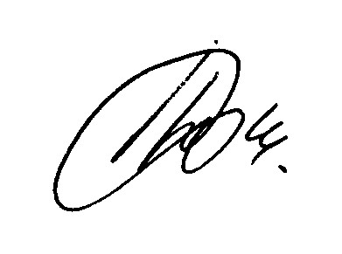 |  | 10 Date: 08.02.2012

