COOMET PROJECT
FINAL REPORT
1. Ref No.:  497/RU-a/10 | 2. Subject field:  CERTIFIED REFERENCE MATERIALS
3. Field of cooperation:
CONSULTATIONS

4. Working Group:
Armenia, Belarus, Georgia, Germany, Kazakhstan, Kyrgyzstan, Lithuania, Moldova, Russia, Ukraine

5. Subject:
Organization and conducting the 15th meeting of COOMET Technical Committee 1.12 “CERTIFIED REFERENCE MATERIALS” (COOMET TC 1.12 “CRMs”).
6. Description:
The 15th meeting of COOMET TC 1.12 “CRMs” was conducted on 21-23 September 2010 (Erevan, Armenia). The representatives from 9 COOMET member-countries took part in the work of the 15th meeting of COOMET TC 1.12 “CRMs”. The following questions were considered: the outcome of the finalized projects in the subject-field “Certified Reference Materials” on the development of COOMET CRMs and the revision of COOMET Recommendation; the progress of the current projects; proposals on new projects; conceptual issues, related to the works on CRM comparison, the results of the 8th meeting of COOMET JCMS and the 20th meeting of COOMET Committee; the information on CRM activity within international organizations ISO/REMCO, COMAR, OIML TC 3/SC 3, CIS, etc. The decisions, taken at the 15th meeting of COOMET TC 1.12 “CRMs” are set out in the Minutes No. 15-2010, translated into English and submitted to COOMET Secretariat.

7. Coordinator’s name: Prof. Vladislav V. Leonov,
Chairman of COOMET TC 1.12 “Certified Reference Materials”,
Director of the Urals Research Institute for Metrology (UNIIM)
Address: 4, Krasnoarmeyskaya Str., 620000, Yekaterinburg, Russia

Telephone: (343) 350 26 18 Fax: (343) 350 20 39 E-mail: uniim@uniim.ru
E-mail: intermetron@uniim.ru

8. Expected completion date:

October 2010

9. Coordinator’s signature:  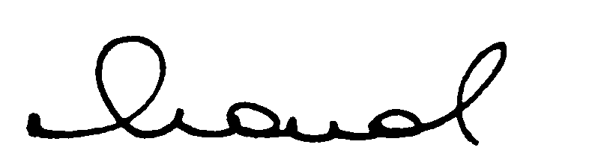 |  | 10. Date:  15.02.2011

