COOMET PROJECT
FINAL REPORT
1 Ref. №:  505/BY-a/10 |  | 2 Subject field:  Information and Training
3 Field of cooperation:
Consultancy and training
4 Working Group:
Armenia, Belarus, Germany, Georgia, Kazakhstan, Kyrgyzstan, Lithuania, Moldova, Russia, Tajikistan, Uzbekistan Ukraine, Uzbekistan

5 Subject:

Organization and realization of a COOMET workshop "Efficient presentations and intercultural awareness" (28-30 of September 2010, Minsk, Belarus)

6 Progress:

There was a COOMET workshop "Efficient presentations and intercultural awareness" on the
28-30 of September 2010 in Minsk, Belarus, where 22 young metrologist from National Metrological Institutions of COOMET member-countries were taking part.

7 Coordinator’s name:
Лобко Владимир Павлович  Ляхова Надежда Дмитриевна  Адрес: БелГИМ, Беларусь г. Минск, Старовиленский тракт, 93  Телефон: +375 17 334-75-40  Факс: +375 17 288-09-38  E-mail: coomet@belgim.by |  |  | Аннета Кеглер  Адрес: Государственный физико-технический институт (ПТБ), Бундесаллее 100, 38116, Брауншвейг, Германия  Телефон: +49 531 592 82 13  Факс: +49 531 592 82 25  E-mail: Annette.Koegler@ptb.de
8 Completion date:

01.10.2010
9 Coordinator’s signature: |  |  |  | 10 Date:  20.10.2010
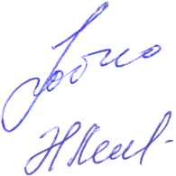 | 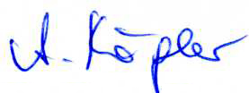 |  |  | 10 Date:  20.10.2010

